Baseline Energy - Analysis Report

The Baseline energy function inputs building-level heating, cooling, and electricity energy meter data and **compares energy use during operating hours and outside operating hours (afterhours) for heating, cooling, and electricity.** This function is intended to help the user assess the effectiveness of schedules and their ability to reduce energy use outside of the building's operating hours. Visualizations compare the energy use rates during and outside operating as a function of outdoor air temperature, and predict energy consumption at representative outdoor air temperatures - these are done separately for heating, cooling, and electrcity. The generated key performance indicators (KPI) quantify schedule effectiveness and afterhours energy use. More information is found in the respective sections.

# Visualizations

The first set of visualizations compare the rate of energy use during operating hours and outside operating hours (afterhours) as a function of outdoor air temperatures - this is done separately for heating, cooling, and electricity. If the afterhours energy use is similiar or identical (in magnitude or degree of inclined slope) to the operating energy use, the current schedules are ineffective in reducing energy use during afterhours. If the slopes are vastly different, the current schedules are effective in reducing energy use outside operating hours.

The second set of visualizations illustrates the predicted sensitivity of energy use on outdoor air temperatures - this is done separately for heating, cooling, and electricity. If the lines are spaced considerably apart, the energy use is particularily sensitive to outdoor air temperature.

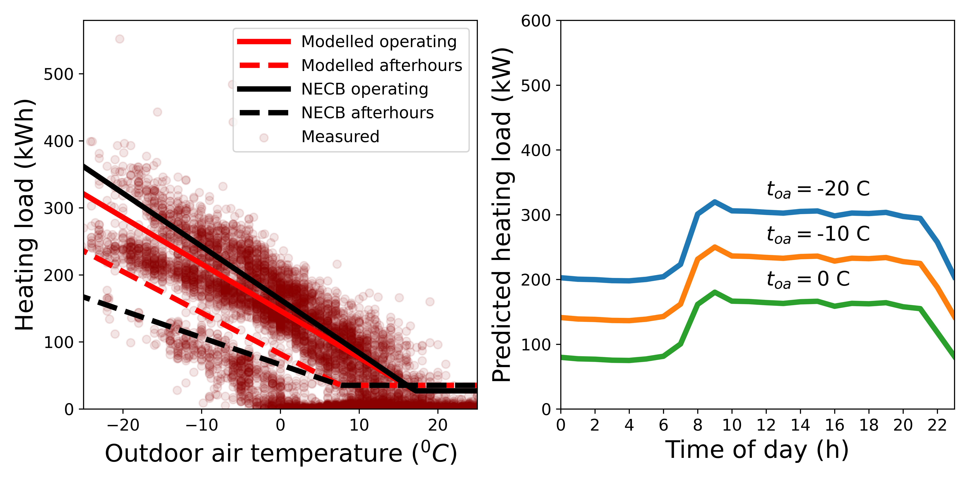

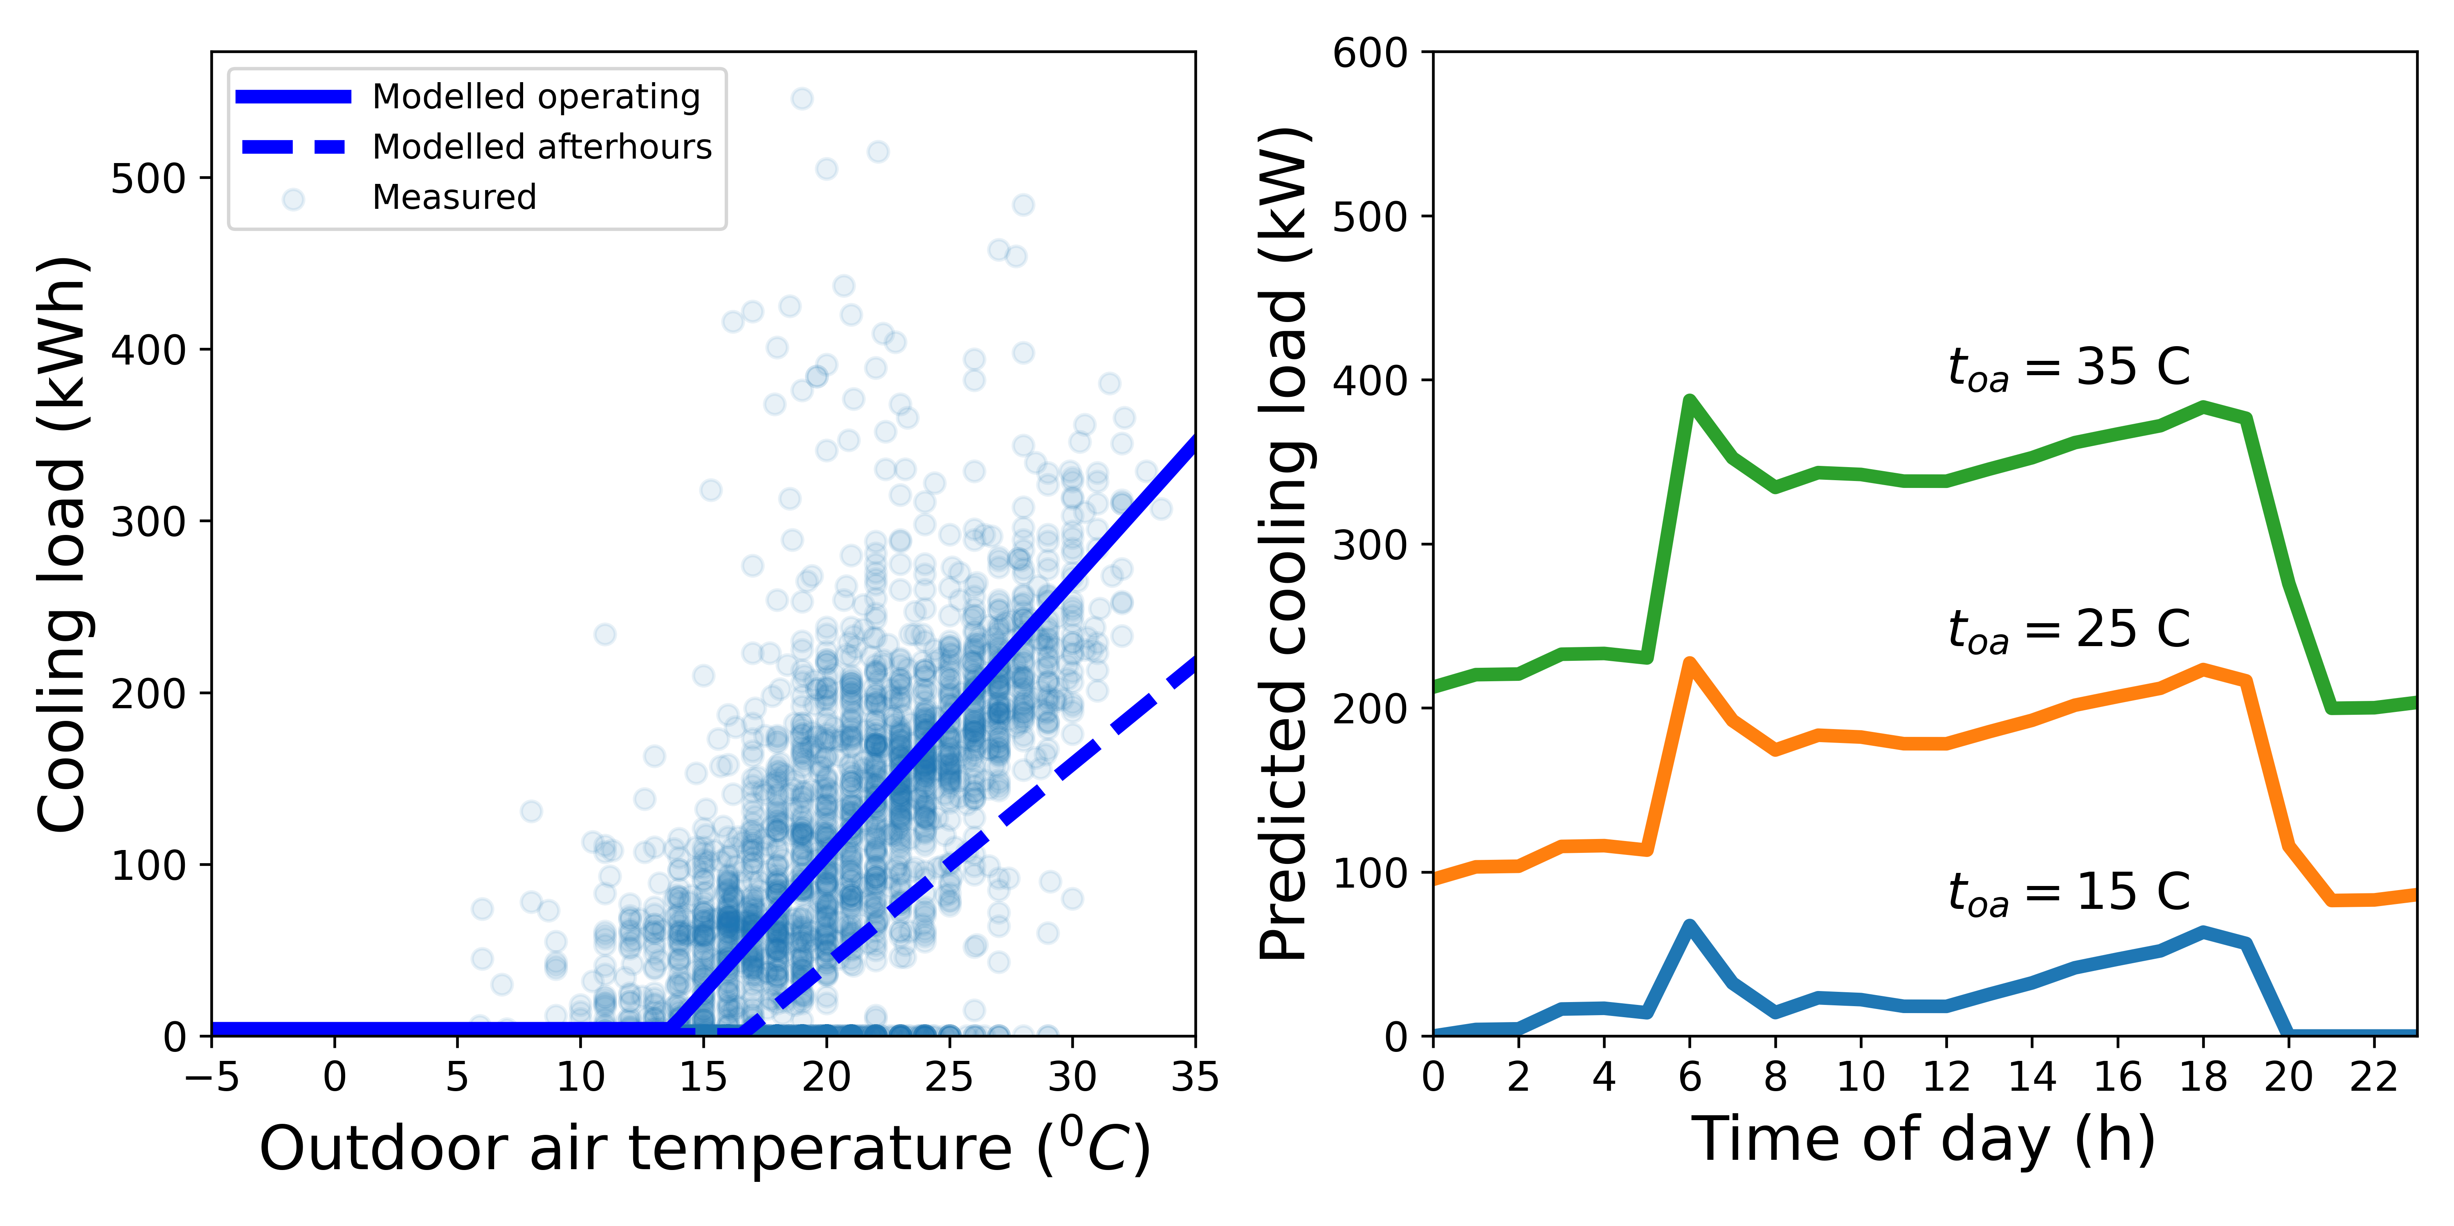

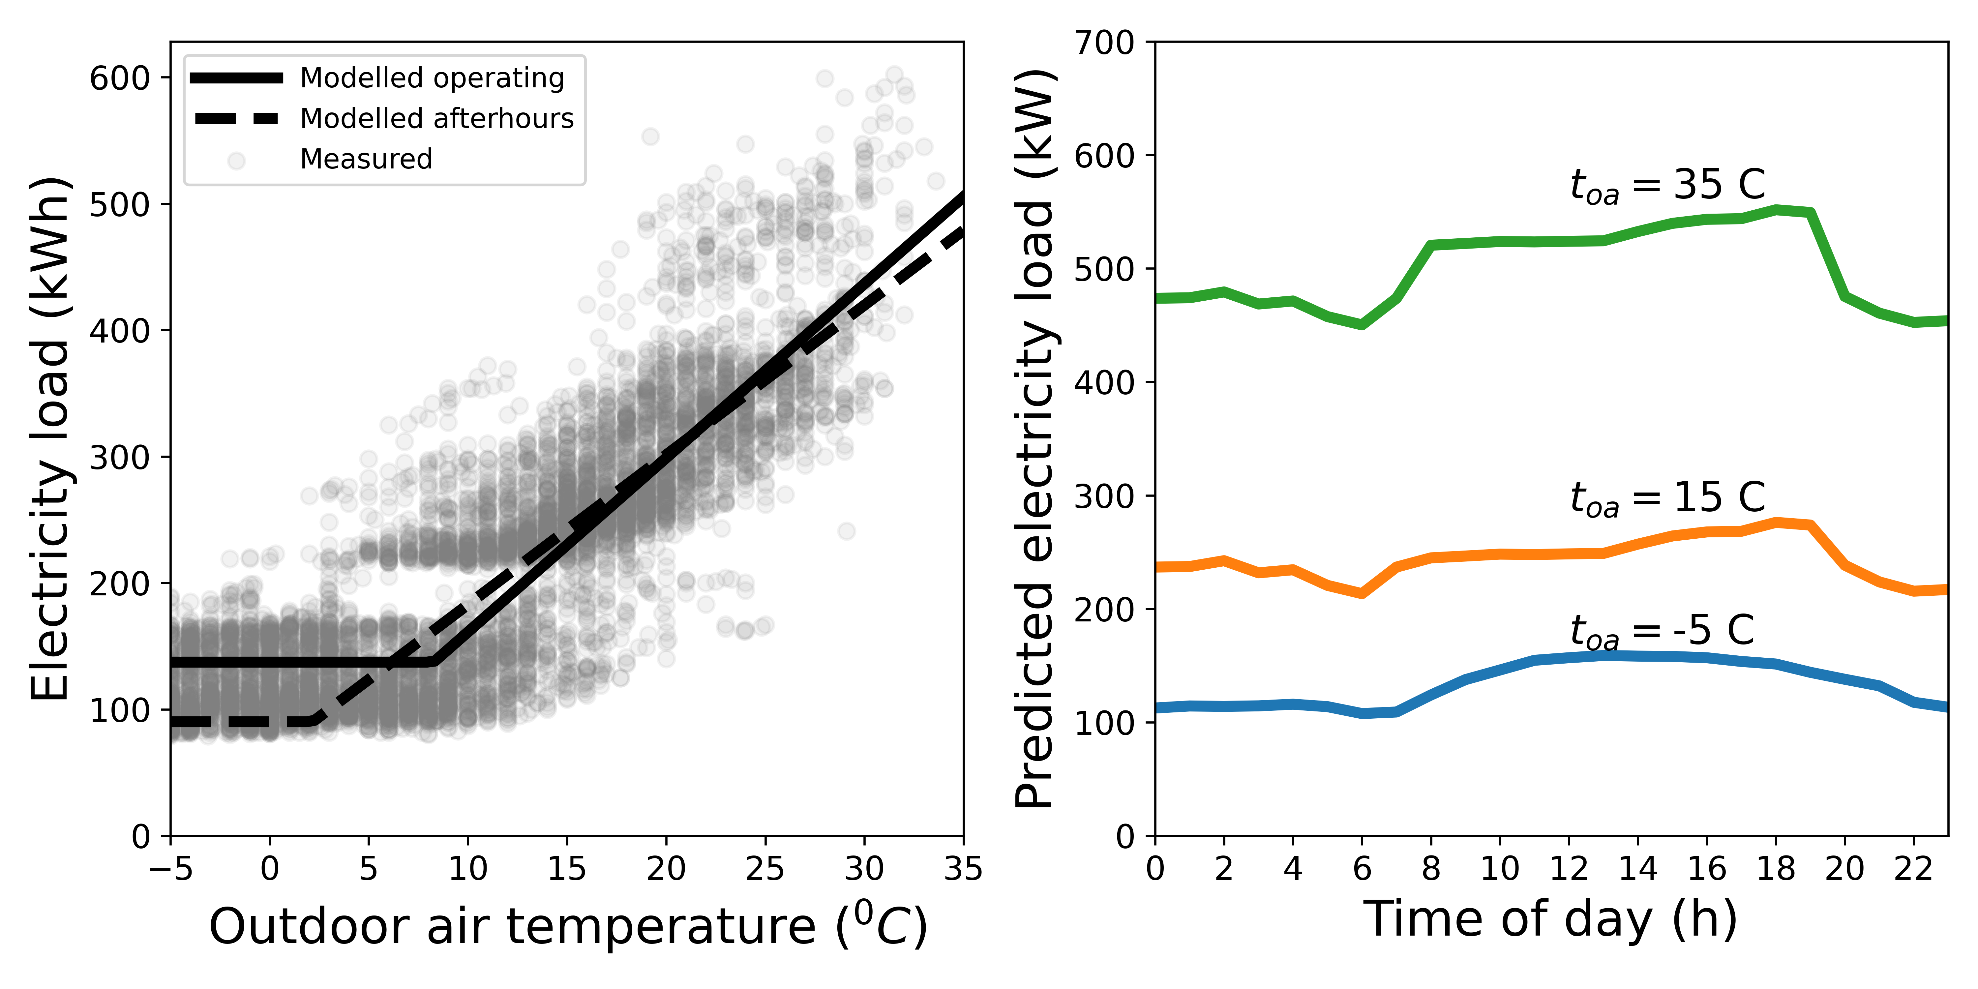

# Key performance Indicators

The generated KPIs are **Schedule effectiveness** and **Afterhours energy use ratio**. Schedule effectiveness quanitfies the difference between the inclined slope of the modeled operating and modeled afterhours energy use rates. Values approaching zero (0) indicate similiar or identical inclined slopes, positive (+) values indcate a steeper operating hours energy use inclined slope, and negative (-) values indicate a steeper afterhours energy use inclined slope. The Afterhours energy use ratio is the ratio of energy use during afterhours over the total energy use.

## Schedule Effectiveness and Afterhours energy use ratio

|  |  |  |
| --- | --- | --- |
| Utility | Schedule Effectivness | After-hours energy use ratio |
| Heating | 0.1186662600475445 | 0.3312472152635019 |
| Cooling | 0.2680102942471242 | 0.0731523050451911 |
| Electricity | 0.1401702556180855 | 0.4482958669162306 |